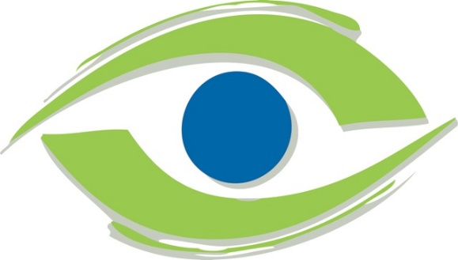
HD Ultra-Wide Field Retina Screening Exam
Early detection of eye disease is critical for your eye health
Ultra-Wide Field Imaging is safe, NEW, and the most advanced digital retinal examination which improves the doctor’s ability to view your retinal health using a high-resolution picture.
- These Ultra-Widefield Images can be done in place of dilation for most routine visits.
- Promotes COVID-19 safety with less face to face provider contact during retinal exam.
- Our doctors recommend this as a baseline for children and annually for adults.
- Our doctors strongly recommend this for patients with a personal or family history of diabetes, hypertension, high cholesterol, glaucoma, macular degeneration, floaters, or retinal detachment.

Traditional Retinal Imaging HD Ultra-Widefield Retinal Imaging

The HD-UWF Retinal Screening Examination is an additional charge of $45 to the basic eye exam:
Please note: Insurance will not cover the HD-UWF Imaging Examination for routine visits.
_______ I AGREE TO have my retinal health evaluated with the HD-UWF Retina Imaging Exam.
_______ I DO NOT wish to have the HD-UWF Retinal Imaging Exam.

__________________________________________________________________________
Patient Signature (Parent if Minor) Date

